5th Grade 2013 Summer Reading List
Fienberg-Fisher K-8 Center

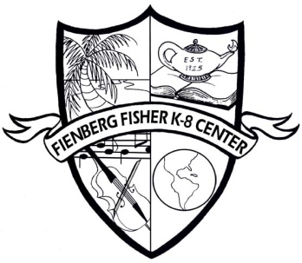

Incoming fifth graders must read two novels from below assigned by the 5th grade teachers. Students are also required to select and complete ONE of the projects for each of the novels. Novel selections are determined by the grade level and IB program and recommended by the 5th grade teacher. Also, your 5th grade teachers will give you an Accelerated Reading test at the beginning of the school year for each novel.

Starring Sally J. Freedman As Herself by Judy Blume
Choose ONE of the following projects. This project is a REQUIRED assignment. Projects are due in the first week of school.
Option #1: The story is about Sally J. Freedman living on Miami Beach. Create a poster size Venn diagram to compare and contrast Sally J. Freedman’s life to your life on Miami Beach. How are your lives different and the same? How is Miami Beach changed from the 1940s, when the story took place, and how it is today?
Option #2: Sally J. Freedman is based on a true story of the author, Judy Blume. The author attended Fienberg-Fisher as a student. Pretend you are a reporter writing an article about students attended or attending Fienberg-Fisher. Write a one page typed or two-page written article including interviews with the author and current Fienberg-Fisher students and similarities of their stories.
Option #3: Think about the main character, Sally. What advice would you give her? What should she do about Mr. Zadovsky? Could she be a film star? Write a letter to Sally that is one page typed or two pages written. Give Sally advice about the boy, Peter. Tell her what you think about Mr. Zadovsky and the likelihood of her becoming a film star.

Island of the Blue Dolphins by Scott O’Dell
Choose ONE of the following projects. This project is a REQUIRED assignment. Projects are due in the first week of school.
Option #1: Imagine a vacation trip to a modern resort on Karana’s warm, tropical island. Feel the refreshing breeze blowing over you as you bask in the sun on the Coral Cove beach at the exclusive Blue Dolphins Vacation Resort. Create an illustrated brochure advertising a week’s vacation on the island. What exciting activities such as swimming with dolphins or hunting abalone, does resort offer to its visitors?
Option #2: In the author’s note at the end of the book, Scott O’Dell mentions Robison Crusoe. Find out more about this other fictional survivor. Was he rescued? Create a Venn Diagram comparing Robison Crusoe and Karana. Then use the diagram to write two paragraphs comparing and contrasting their stories.
Option #3: Did Aleuts, Russians, and people from other countries really visit the island home of Karana’s people? Research to learn more about the exploration of the Channel islands. List the countries whose people visited the islands. List the purpose and approximate dates of the visits. Then create a chart to organize the information in a way that is easy to read.

